* Majority of losses on the left flank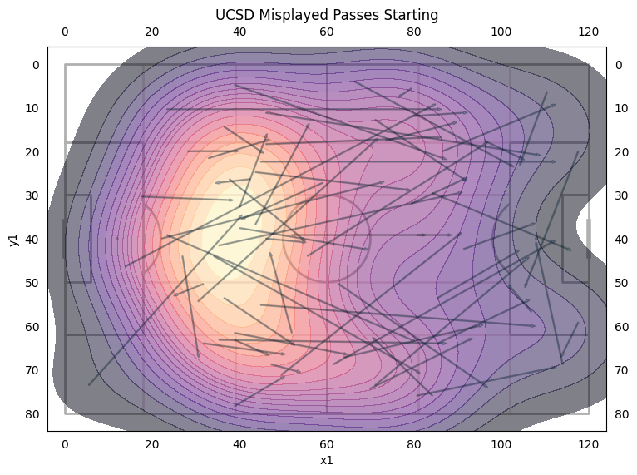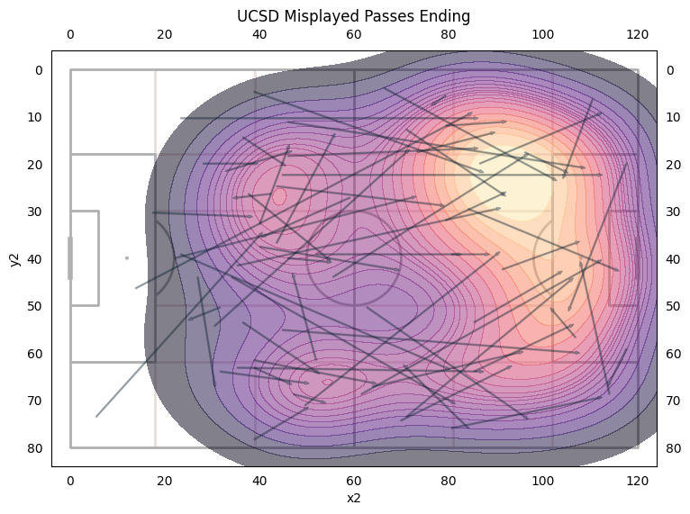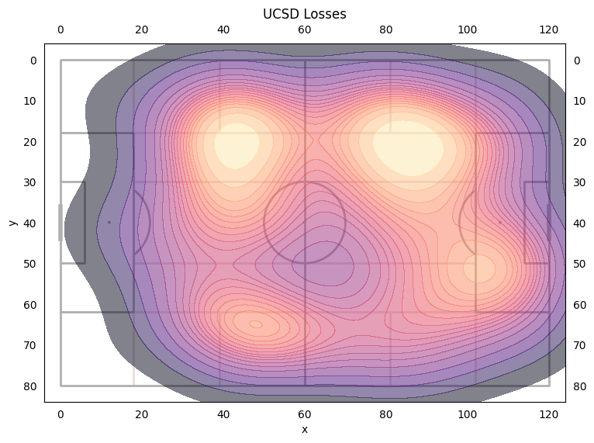
* 65% of the losses were duels
* 35% of the losses were misplayed passes/crosses
* Max had the most losses at 15, then Quinn, Adam, and Val at 11.
* Defensive duels win rate at 58% a 7% drop from Duke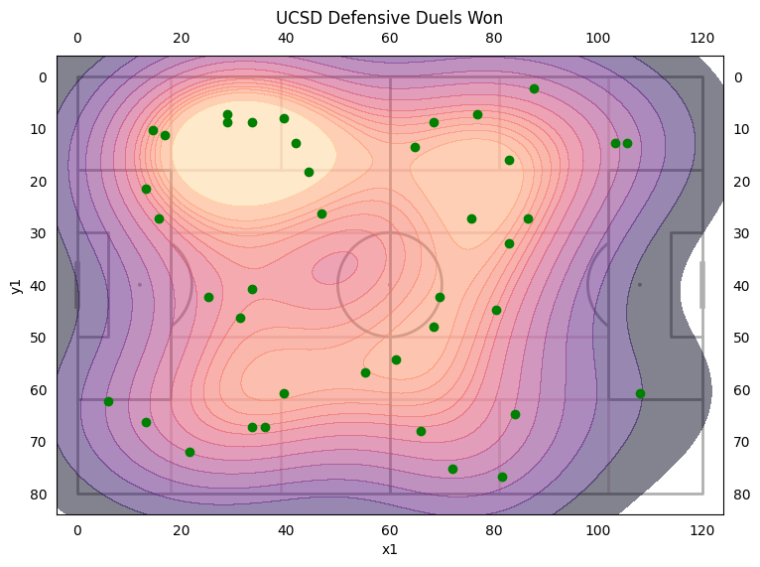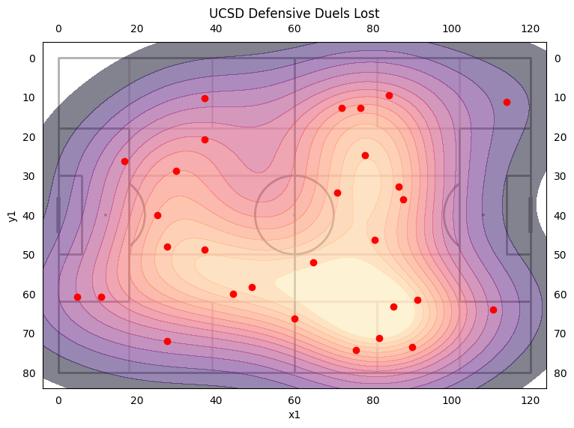
* Majority of duels were won on the left side.
* Quin, Adam, and Woody had 7 defensive duels and won 71%. Evan was at 100% and won 3.
* Majority of offensive duels were lost on the right side while the majority of won duels were on the left but is a little more balanced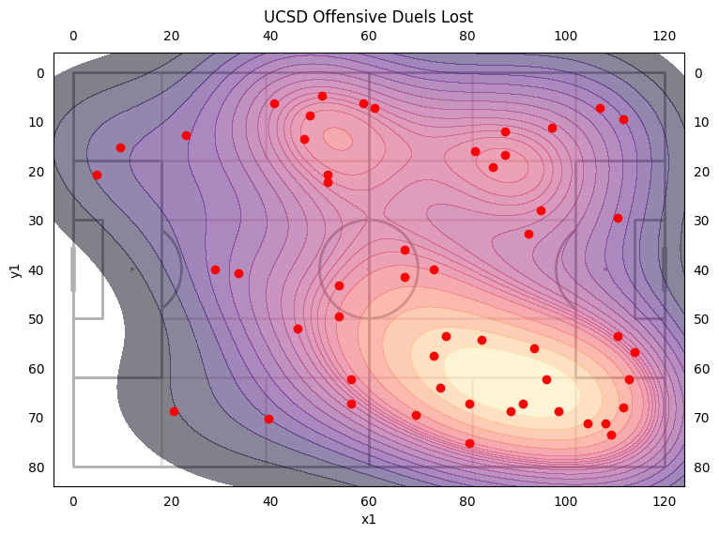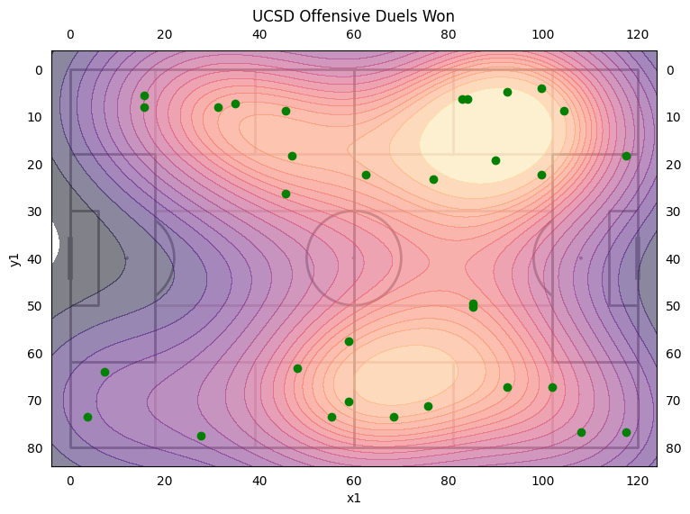
* Max had the most offensive duels at 12 but only won 8%
* Kai had 10 and won 40%
* Jonah had 5 and won 0%
* Cole (9 duels) and James (7 duels) were most successful at 56% and 57% respectively.

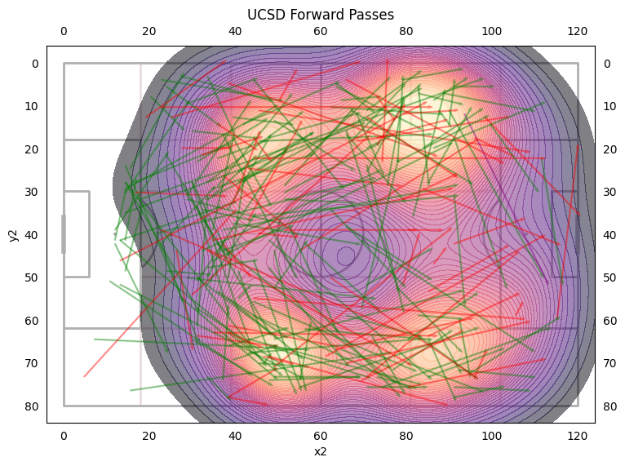

* 6% increase in forward pass accuracy from Duke (62% → 68%)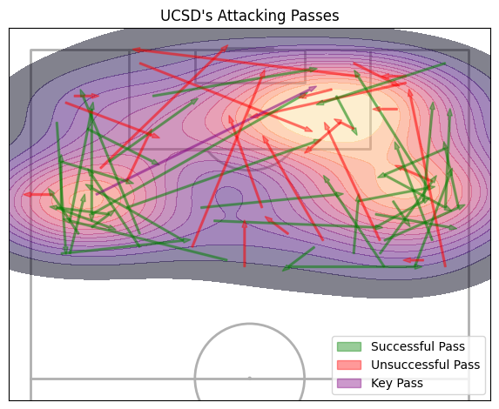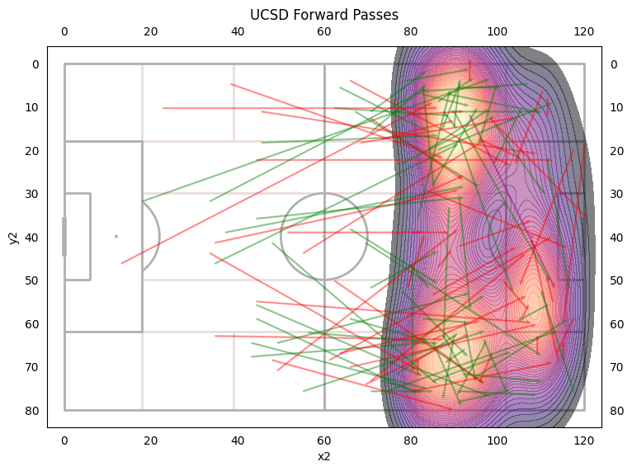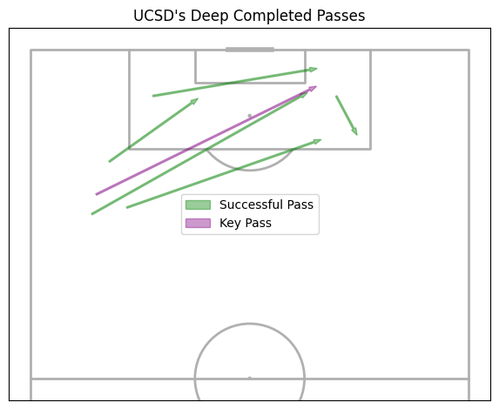
* 12% decrease in passes into final third accuracy from Duke (65% → 53%)
* Forward passes were fairly balanced between left and right with only 15 more passes on the right side than left.
* Pass accuracy on the left side was 74.8%
* Pass accuracy on the right side was 77.5%
* Pass accuracy when switching sides is 80%
* Player with more than 10 forward passes
  + Adam had a 79% accuracy, Carter had a 78% accuracy, Cole had a 71% accuracy, Evan had a 81% accuracy, James had a 63% accuracy, Jonah had a 84% accuracy, Nolan had a 79% accuracy, Quin had a 59% accuracy
* UCSD had 7 deep completed passes, the same as the Duke game.
* Utah Valley only had 4 deep completed passes into the box.